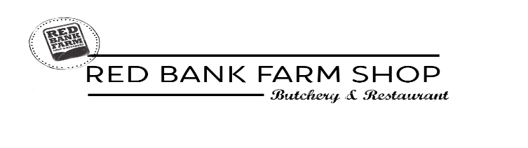
Free Range Bronze Whole Turkeys Red Bank Farm 28 Dry Aged Beef
Avg weight serves £/kg Avg price Qty Cut serves approx. £/kg Qty
Rib of Beef (2 Rib) 4-6 £16.20
Rib of Beef (4 Rib) 6-8 £16.20
Fillet of Beef (1kg) 4 £35.65
Fillet of Beef (2kg) 8 £35.65
Sirloin Roast (2kg) 8-10 £28.05
Topside Roast (1.5kg) 6-8 £12.75
Topside Roast (2.5kg) 8-10 £12.75
3kg 4-6 £14.85 £44.55
4kg 6-8 £14.85 £59.40
5kg 8-10 £14.05 £70.25
6kg 10-12 £14.05 £84.30
7kg 12-14 £12.95 £90.65
8kg 14-16 £12.95 £103.60
9kg 16-18 £12.20 £109.80
10kg 18-20 £12.20 £122.00

Free Range Bronze Turkey Crowns Pork, Lamb and Gammon
Avg weight serves £/kg Avg price Qty Cut £/kg Qty
3kg 4 £17.25 £51.75
4kg 6 £17.25 £69.00
5kg 8 £17.25 £86.25
6kg 10 £17.25 £103.50
Gammon Joint 2.5kg £10.90
Pork Leg Roast 2.5kg £9.41
Rack of Pork Loin £12.41
Leg of Lamb 2.5kg £12.50
Lamb Shank £6/each
Free Range Turkey Breast Joint Assorted Birds
Goose 6kg £12.58
Whole Duck 3kg £11.00
Whole Chicken 1.9kg £5.00
Capon 4kg £8.00
Pheasant Brace £10.00
Avg weight serves £/kg Avg price Qty Avg weight £/kg Qtr
1kg 4 £23.80 £23.80
2kg 6 £23.80 £47.60

Stuffed Breast Roast
Three Bird Roast, Bronze turkey breast with Duck, Pheasant and cranberry & orange stuffing. £65/each
Stuffed Turkey Breast, Bronze turkey breast roast, with sausage cranberry & orange stuffing. £45/each
Pigs in Blankets 12 £4.00
Chipolatas 12 £3.00
Sage & onion stuffing balls 6 £4.00
Sausage meat 452g £3.00
Sausages and Stuffing

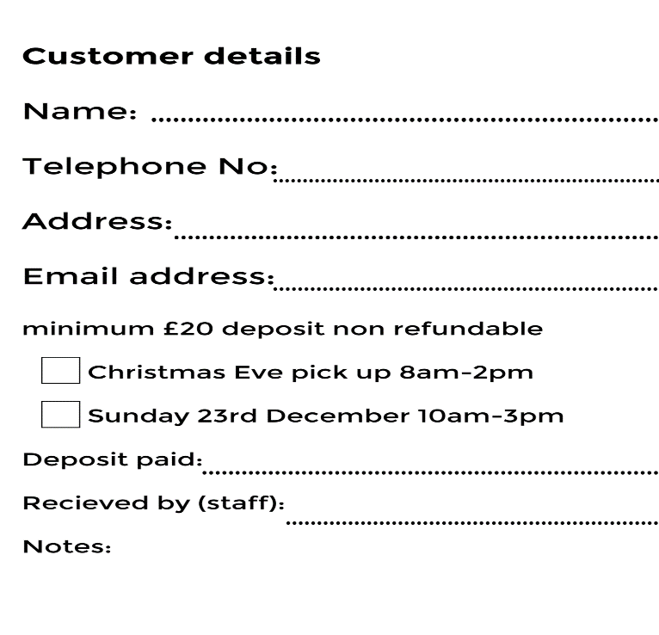
Indoor White Turkey
Avg weight serves £/kg Avg price Qty
4kg 6-8 £10.90 £43.60
5kg 8-10 £10.90 £54.50
6kg 10-12 £10.90 £65.40

*please note the final price of your turkey/meat will be based on the finalweight in kilos. 